Mammal Life Cycle
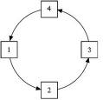
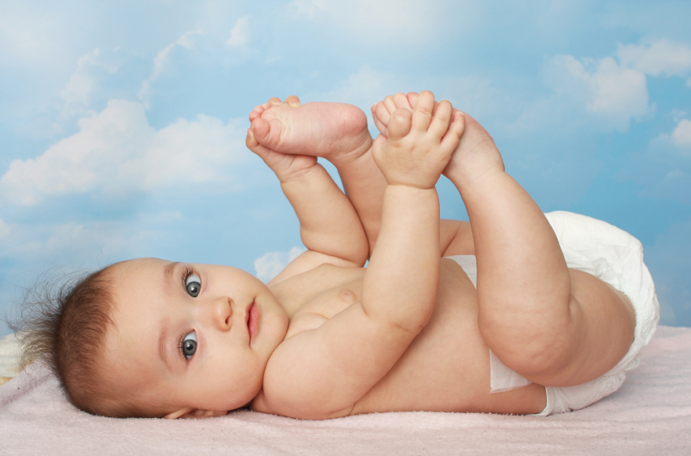
Wordle

Name:________________________ Period:___________

Directions: Please state the animal you have selected to do this project on and use the suggested sites to answer the following questions.

Animal:________________________ (Mrs. Turner must approve this animal before you start work )

San Diego Zoo, Animal Planet, National Geographic, United States Parks and National Wildlife Foundation ( all sites are linked on the library website under health ) ** YOU MAY NOT USE WIKIPEDIA **

- Does your mammal practice monogamy? ( Does it mate for life, or have several mates? )
______________________________________________________________________________________________________________________________________________________________________________________________________________________________________________________________________________

2. How long is your mammal pregnant for and explain their pregnancy process. (Is the male part of the birth? Where does the birth take place? Do many of the young survive? What are the babies called? How much do the babies weight?)
______________________________________________________________________________________________________________________________________________________________________________________________________________________________________________________________________________

3. How many offspring are typically produced by your mammal?
________________________________________________________________________________________________________________________________________________________________________________________________________________________

4. At what age and what time of year can your mammal get pregnant?
__________________________________________________________________________________________________________________________________________________________________
___________________________________________________________

5. After birth what type of care does your mammal provide for its young? (Does it leave the baby? Does it stay with the baby? Does the baby live with the mother? Are the mothers violent with their young? Are the mothers protective? )

________________________________________________________________________________________________________________________________________________________________________________________________________________________
________________________________________________________________________________________________________________________________________________________________________________________________________________________

Poster Directions: Fill out the following sheet to help you prepare your poster. Your poster will contain a picture of your animal and 6 facts that explain the reproduction cycle of your animal. They must be appropriate. Three topics are provided for you and MUST be on your poster. The other three facts you may select. Pick facts that are interesting. Try to find out things that your classmates probably do not know. Complete this worksheet and then create your poster using WORD. You may put your facts on a large poster board or you may print the WORD project.

. NAME OF YOUR ANIMAL.
-
1. HOW LONG YOUR ANIMAL PREGNANT FOR
-
2. HOW MUCH DOES A BABY WEIGHT
-
3. THE NAME OF THE BABY
-
4. Your choice
-
5. Your choice
-
6. Your choice
-

- Do not forget you need a picture ☺

**When you are finished I must okay your poster before you print. Your poser and this worksheet will be turned in for a project/test grade.**

☺ Good Luck ☺

